Travis Hutchinson

CS-250: Sprint Review and Retrospective

Oct. 18, 2024

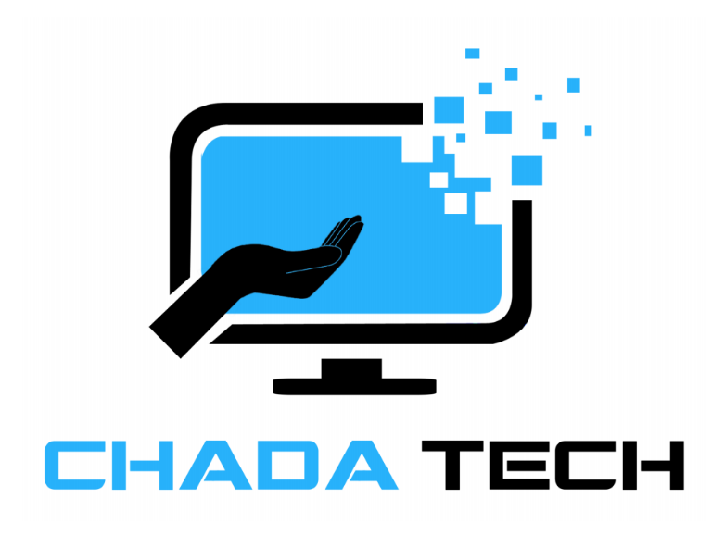

* **Applying Roles: Demonstrate how the various roles on your Scrum-Agile Team specifically contributed to the success of a project. Use specific examples from your experiences.**

**Product Owner:** I acted as a liaison between the stakeholders and the development team. My other contribution was collecting the requirements needed to create the User Stories for our Development team from the stakeholders.

**Scrum Master:** Servant leader involved with Sprint Planning, Daily Scrums, Backlog Refinement, Sprint Review, and Sprint Retrospective. I created our team charter, and helped contribute to the team’s success by encouraging participation, facilitating collaboration, identifying areas for improvement, refining the product backlog, and resolving any conflicts/impediments the team was facing.

**Tester:** Developed several initial test cases based upon the User Stories, then revised said test cases. These test cases provide clear conditions that must be met for a feature to be considered complete, assigning a Pass/Fail based on the outcome of the expected results.

**Developer:** Used the updated requirements switching the SNHU Travel project from Trendy/Niche packages to Wellness/Detox vacations. Swapping out the pictures and text from the previous version of the product was a smooth process due to our Agile approach.

* **Completing User Stories: Describe how a Scrum-Agile approach to the software development life cycle (SDLC) helped user stories come to completion. Use specific examples from your experiences.**

User Stories were a vital tool that helped our Scrum Team stay aligned with the user’s needs, enhanced collaboration, and helped deliver valuable increments of work effectively. User stories play a crucial role in helping the Scrum Team in several ways such as:

**Clarity and Focus**: User stories provide a clear understanding of what needs to be built from the user’s perspective, ensuring the team knows the value and purpose of each task.

**Prioritization**: They help in prioritizing work based on user needs and business value, allowing the team to focus on the most important features first.

**Flexibility**: After receiving feedback, user stories can then be easily modified; allowing the team to adapt to changing requirements and insights from users.

* **Handling Interruptions: Describe how a Scrum-Agile approach supported project completion when the project was interrupted and changed direction. Use specific examples from your experiences.**

The Scrum-Agile approach was perfect for its ability to adapt when a project needs to change course. For example, the change in direction for the SNHU Travel project to focus on “Wellness/Detox” packages instead of “Trendy/Niche” travel locations allowed us to take what was already in development and change the code to support the new requirement. Agile allowed for a smooth transition without having to start the project over from scratch, costing time and money.

* **Communication: Demonstrate your ability to communicate effectively with your team by providing samples of your communication. Explain why your examples were effective in their context and how they encouraged collaboration among team members.**

I feel the strongest example was during the 6-2 Discussion: Agreed Upon Agile Practice. I had set up a new thread for us to discuss/vote for our “single” agreed upon practice for the group submission:

“Hey Team!

This thread is for the agreed upon Agile practice. Please feel free to reply below with your selected practice by this Sunday (Oct. 13). Hopefully we can come together on a single practice, otherwise the practice with the most submissions will be our chosen method. Thank you for your participation and have a great weekend everybody.

Travis H. (Product Owner)”

As the group cast their votes, we awaited the response of our final team member, James. However, our Scrum Master (James Chase) interpreted the assignment in a different way and communicated it perfectly:

“Hey all,

Reviewing the Guidelines and Rubric for the assignment I am seeing "**collaborate with your teammates** to reach an agreement on the implementation of one practice recommended by each team member. " I am reading that as we need to pull one practice for each of us, for a total of 5 agile practices recommend.  I definitely agree with everyone that the Daily Scrum should be implemented.  I am specifically going to pull that from Lionell (Developer) as multiple people recommended this.  I would like to pull from Travis (Product Owner) to recommend Backlog Management (particularly important for the company situation).  Then from Shawn (Tester) I would like to focus on using test-driven development and from Jeff (Developer) sprint planning within a defined time slot.  Finally, from my own recommendations (Scrum Master) I would put forward sprint retrospectives (particularly important with a new and developing agile adoption).

So to clean it up:

* Travis: Backlog Management
* Jeff: Sprint Planning with defined time boxes
* Lionell: Daily Scrum
* Shawn: Test Driven Development
* James: Sprint Retrospective

I think with these selections we are able to tackle the core framework of Agile as we have adopted an Agile work prioritization standards, an agile meeting standard, an agile planning standard, an agile reflection standards, and an agile development style standard.  I believe this provides Vision Quest a solid starting grounds for Agile adoption.

If I am wrong on how the assignment is worded then forget the rest of this and the Daily Scrum is my vote.

-James Chase”

Because of James’ observation and his ability to effectively communicate, this new information allowed the team to respond and adapt to the conversation; encouraging collaboration and engagement.

* **Organizational Tools: Evaluate the organizational tools and Scrum-Agile principles that helped your team be successful. Reference the Scrum events in relation to the effectiveness of the tools.**

There were several Organizational Tools and Scrum-Agile Principles that played a crucial role in our team's success. For example, during the **Sprint Planning** we utilized tools like **Jira** which allowed us to visually organize our tasks, prioritize the backlog items, and clarify the team’s goals for each sprint. This ensured everyone on the team was aligned and aware of their responsibilities.

* **Evaluating Agile Process: Assess the effectiveness of the Scrum-Agile approach for a specific project. Address each of the following:**
  + **Describe the pros and cons that the Scrum-Agile approach presented during the SNHU Travel project.**

The Scrum-Agile approach presented several advantages and disadvantages during the SNHU Travel project. Some of the **“Pros”** for example include Scrum-Agile’s **Flexibility and Adaptability,** which allowed for changes in the requirements even late in the development process, which is beneficial for a travel project where customer needs may evolve. We also used **Daily Stand-ups** and **Sprint Reviews** topromote team communication and collaboration, helping to identify issues early. Other **“Pros”** I would include would be Scrum’s transparency and breaking down the process into incremental **Sprints** (typically 2-4 weeks), providing opportunities for feedback and adjustments based on stakeholder input.

While the Scrum-Agile approach has many advantages, it also has its disadvantages. In my opinion the biggest disadvantage would be its initial learning curve. If a team is new to Scrum, there could be a learning curve that may slow down initial progress. Success also heavily relies on the team’s **commitment and collaboration**. If team members are not fully engaged, productivity can suffer. Agile’s flexibility can also lead to **Scope Creep** if not managed carefully, as new ideas or changes may continually be introduced.

* + **Determine whether or not a Scrum-Agile approach was the best approach for the SNHU Travel development project.**

Overall, I think the implementation of Agile to the SNHU Travel project was a great choice because it allowed for greater transparency and more flexibility. We also decreased the risk of having missed a critical requirement of the customer. In the end, a quality product was delivered that satisfied both the Development Team and the customer.